Assignment 3
CSA05 Database Management Systems – CO3: ShopNest Online Retail Order Database – Normalisation (MySQL)

Queries

A. Create database and tables
- CREATE DATABASE IF NOT EXISTS shopnest_co3;
- USE shopnest_co3;
- CREATE TABLE order_line (
order_id INT NOT NULL,
order_date DATE NOT NULL,
customer_id INT NOT NULL,
customer_name VARCHAR(100) NOT NULL,
customer_email VARCHAR(100) NOT NULL,
ship_street VARCHAR(100) NOT NULL,
ship_city VARCHAR(60) NOT NULL,
ship_pin CHAR(6) NOT NULL,
ship_state VARCHAR(60) NOT NULL,
product_id INT NOT NULL,
product_name VARCHAR(100) NOT NULL,
unit_price DECIMAL(10,2) NOT NULL,
category_id INT NOT NULL,
category_name VARCHAR(60) NOT NULL,
supplier_id INT NOT NULL,
supplier_name VARCHAR(100) NOT NULL,
supplier_phone VARCHAR(15) NOT NULL,
quantity INT NOT NULL,
warehouse_id INT NOT NULL,
warehouse_city VARCHAR(60) NOT NULL,
tag_list VARCHAR(100),
colour_list VARCHAR(100),
PRIMARY KEY (order_id, product_id),
CHECK (quantity > 0),
CHECK (unit_price > 0)
);
- CREATE TABLE customer (
customer_id INT PRIMARY KEY,
customer_name VARCHAR(100) NOT NULL,
customer_email VARCHAR(100) NOT NULL UNIQUE
);
- CREATE TABLE pin_area (
ship_pin CHAR(6) PRIMARY KEY,
ship_city VARCHAR(60) NOT NULL,
ship_state VARCHAR(60) NOT NULL
);
- CREATE TABLE category (
category_id INT PRIMARY KEY,
category_name VARCHAR(60) NOT NULL
);
- CREATE TABLE supplier (
supplier_id INT PRIMARY KEY,
supplier_name VARCHAR(100) NOT NULL,
supplier_phone VARCHAR(15) NOT NULL
);
- CREATE TABLE warehouse (
warehouse_id INT PRIMARY KEY,
warehouse_city VARCHAR(60) NOT NULL
);
- CREATE TABLE product (
product_id INT PRIMARY KEY,
product_name VARCHAR(100) NOT NULL,
unit_price DECIMAL(10,2) NOT NULL,
category_id INT NOT NULL,
supplier_id INT NOT NULL,
FOREIGN KEY (category_id) REFERENCES category(category_id),
FOREIGN KEY (supplier_id) REFERENCES supplier(supplier_id),
CHECK (unit_price > 0)
);
- CREATE TABLE orders (
order_id INT PRIMARY KEY,
order_date DATE NOT NULL,
customer_id INT NOT NULL,
ship_street VARCHAR(100) NOT NULL,
ship_pin CHAR(6) NOT NULL,
FOREIGN KEY (customer_id) REFERENCES customer(customer_id),
FOREIGN KEY (ship_pin) REFERENCES pin_area(ship_pin)
);
- CREATE TABLE order_item (
order_id INT NOT NULL,
product_id INT NOT NULL,
quantity INT NOT NULL,
warehouse_id INT NOT NULL,
PRIMARY KEY (order_id, product_id),
FOREIGN KEY (order_id) REFERENCES orders(order_id),
FOREIGN KEY (product_id) REFERENCES product(product_id),
FOREIGN KEY (warehouse_id) REFERENCES warehouse(warehouse_id),
CHECK (quantity > 0)
);
- CREATE TABLE product_tag (
product_id INT NOT NULL,
tag VARCHAR(30) NOT NULL,
PRIMARY KEY (product_id, tag),
FOREIGN KEY (product_id) REFERENCES product(product_id)
);
- CREATE TABLE product_colour (
product_id INT NOT NULL,
colour VARCHAR(30) NOT NULL,
PRIMARY KEY (product_id, colour),
FOREIGN KEY (product_id) REFERENCES product(product_id)
);
- CREATE TABLE product_tag_colour (
product_id INT NOT NULL,
tag VARCHAR(30) NOT NULL,
colour VARCHAR(30) NOT NULL,
PRIMARY KEY (product_id, tag, colour)
);
- CREATE TABLE supply (
supplier_id INT NOT NULL,
category_id INT NOT NULL,
warehouse_id INT NOT NULL,
PRIMARY KEY (supplier_id, category_id, warehouse_id)
);
- CREATE TABLE supplier_category (
supplier_id INT NOT NULL,
category_id INT NOT NULL,
PRIMARY KEY (supplier_id, category_id)
);
- CREATE TABLE category_warehouse (
category_id INT NOT NULL,
warehouse_id INT NOT NULL,
PRIMARY KEY (category_id, warehouse_id)
);
- CREATE TABLE supplier_warehouse (
supplier_id INT NOT NULL,
warehouse_id INT NOT NULL,
PRIMARY KEY (supplier_id, warehouse_id)
);
- SHOW TABLES;

B. Insert sample data (12 order lines, unnormalised table)
- INSERT INTO order_line VALUES
(1001,'2026-10-01',1,'Arun Kumar','arun@mail.com','Anna Salai','Chennai','600002','Tamil Nadu',1,'Wireless Mouse',799.00,10,'Electronics',501,'TechSource','9840011111',2,1,'Chennai','wireless,usb','black,white'),
(1001,'2026-10-01',1,'Arun Kumar','arun@mail.com','Anna Salai','Chennai','600002','Tamil Nadu',2,'Notebook A5',120.00,20,'Stationery',502,'PaperWorld','9840022222',5,2,'Madurai','ruled,spiral','blue'),
(1002,'2026-10-03',2,'Meena Devi','meena@mail.com','Bypass Road','Madurai','625010','Tamil Nadu',1,'Wireless Mouse',799.00,10,'Electronics',501,'TechSource','9840011111',1,1,'Chennai','wireless,usb','black,white'),
(1002,'2026-10-03',2,'Meena Devi','meena@mail.com','Bypass Road','Madurai','625010','Tamil Nadu',3,'Steel Bottle',350.00,30,'Kitchen',503,'HomeCraft','9840033333',2,3,'Coimbatore','insulated,leakproof','silver,black'),
(1003,'2026-10-05',3,'Karthik R','karthik@mail.com','Race Course Rd','Coimbatore','641018','Tamil Nadu',4,'USB Keyboard',650.00,10,'Electronics',501,'TechSource','9840011111',1,1,'Chennai','usb','black'),
(1003,'2026-10-05',3,'Karthik R','karthik@mail.com','Race Course Rd','Coimbatore','641018','Tamil Nadu',2,'Notebook A5',120.00,20,'Stationery',502,'PaperWorld','9840022222',10,2,'Madurai','ruled,spiral','blue'),
(1004,'2026-10-08',1,'Arun Kumar','arun@mail.com','Mount Road','Chennai','600002','Tamil Nadu',3,'Steel Bottle',350.00,30,'Kitchen',503,'HomeCraft','9840033333',1,3,'Coimbatore','insulated,leakproof','silver,black'),
(1004,'2026-10-08',1,'Arun Kumar','arun@mail.com','Mount Road','Chennai','600002','Tamil Nadu',4,'USB Keyboard',650.00,10,'Electronics',501,'TechSource','9840011111',3,1,'Chennai','usb','black'),
(1005,'2026-10-10',2,'Meena Devi','meena@mail.com','Bypass Road','Madurai','625010','Tamil Nadu',2,'Notebook A5',120.00,20,'Stationery',502,'PaperWorld','9840022222',4,2,'Madurai','ruled,spiral','blue'),
(1005,'2026-10-10',2,'Meena Devi','meena@mail.com','Bypass Road','Madurai','625010','Tamil Nadu',4,'USB Keyboard',650.00,10,'Electronics',501,'TechSource','9840011111',1,1,'Chennai','usb','black'),
(1006,'2026-10-12',3,'Karthik R','karthik@mail.com','Race Course Rd','Coimbatore','641018','Tamil Nadu',1,'Wireless Mouse',799.00,10,'Electronics',501,'TechSource','9840011111',1,1,'Chennai','wireless,usb','black,white'),
(1006,'2026-10-12',3,'Karthik R','karthik@mail.com','Race Course Rd','Coimbatore','641018','Tamil Nadu',3,'Steel Bottle',350.00,30,'Kitchen',503,'HomeCraft','9840033333',3,3,'Coimbatore','insulated,leakproof','silver,black');
- INSERT INTO customer SELECT DISTINCT customer_id, customer_name, customer_email FROM order_line;
- INSERT INTO pin_area SELECT DISTINCT ship_pin, ship_city, ship_state FROM order_line;
- INSERT INTO category SELECT DISTINCT category_id, category_name FROM order_line;
- INSERT INTO supplier SELECT DISTINCT supplier_id, supplier_name, supplier_phone FROM order_line;
- INSERT INTO warehouse SELECT DISTINCT warehouse_id, warehouse_city FROM order_line;
- INSERT INTO product SELECT DISTINCT product_id, product_name, unit_price, category_id, supplier_id FROM order_line;
- INSERT INTO product VALUES (5,'Laptop Bag',1499.00,30,503);
- INSERT INTO orders SELECT DISTINCT order_id, order_date, customer_id, ship_street, ship_pin FROM order_line;
- INSERT INTO order_item SELECT order_id, product_id, quantity, warehouse_id FROM order_line;
- INSERT INTO product_tag VALUES
(1,'wireless'),(1,'usb'),(2,'ruled'),(2,'spiral'),(3,'insulated'),(3,'leakproof'),(4,'usb'),
(5,'travel'),(5,'laptop'),(5,'waterproof'),(5,'padded'),(5,'lightweight');
- INSERT INTO product_colour VALUES
(1,'black'),(1,'white'),(2,'blue'),(3,'silver'),(3,'black'),(4,'black'),
(5,'black'),(5,'grey'),(5,'navy'),(5,'red');
- INSERT INTO product_tag_colour
SELECT t.product_id, t.tag, c.colour
FROM product_tag t JOIN product_colour c ON c.product_id = t.product_id;
- INSERT INTO supply VALUES (501,10,1),(501,10,2),(501,20,1),(501,20,2),(502,10,1),(502,20,1);
- INSERT INTO supplier_category SELECT DISTINCT supplier_id, category_id FROM supply;
- INSERT INTO category_warehouse SELECT DISTINCT category_id, warehouse_id FROM supply;
- INSERT INTO supplier_warehouse SELECT DISTINCT supplier_id, warehouse_id FROM supply;

C. Row counts
- SELECT COUNT(*) AS Order_Line_Rows FROM order_line;
- SELECT COUNT(*) AS Customers FROM customer;
- SELECT COUNT(*) AS Products FROM product;
- SELECT COUNT(*) AS Suppliers FROM supplier;
- SELECT COUNT(*) AS Orders_Count FROM orders;
- SELECT COUNT(*) AS Order_Items FROM order_item;

D. Task 1 and 3 – Functional dependency verification (0 rows = FD holds)
- -- FD1: customer_id -> customer_name, customer_email
SELECT customer_id, COUNT(DISTINCT customer_name) AS names
FROM order_line GROUP BY customer_id HAVING COUNT(DISTINCT customer_name) > 1 OR COUNT(DISTINCT customer_email) > 1;
- -- FD2: product_id -> product_name, unit_price, category_id, supplier_id
SELECT product_id FROM order_line
GROUP BY product_id
HAVING COUNT(DISTINCT product_name) > 1 OR COUNT(DISTINCT unit_price) > 1
OR COUNT(DISTINCT category_id) > 1 OR COUNT(DISTINCT supplier_id) > 1;
- -- FD3 (transitive): category_id -> category_name
SELECT category_id FROM order_line GROUP BY category_id HAVING COUNT(DISTINCT category_name) > 1;
- -- FD4 (transitive): supplier_id -> supplier_name, supplier_phone
SELECT supplier_id FROM order_line GROUP BY supplier_id
HAVING COUNT(DISTINCT supplier_name) > 1 OR COUNT(DISTINCT supplier_phone) > 1;
- -- FD5: order_id -> order_date, customer_id, ship_street, ship_pin
SELECT order_id FROM order_line GROUP BY order_id
HAVING COUNT(DISTINCT order_date) > 1 OR COUNT(DISTINCT customer_id) > 1
OR COUNT(DISTINCT ship_street) > 1 OR COUNT(DISTINCT ship_pin) > 1;
- -- FD6: ship_pin -> ship_city, ship_state
SELECT ship_pin FROM order_line GROUP BY ship_pin
HAVING COUNT(DISTINCT ship_city) > 1 OR COUNT(DISTINCT ship_state) > 1;
- -- FD7: (ship_street, ship_city) -> ship_pin
SELECT ship_street, ship_city FROM order_line
GROUP BY ship_street, ship_city HAVING COUNT(DISTINCT ship_pin) > 1;
- -- FD8: warehouse_id -> warehouse_city
SELECT warehouse_id FROM order_line GROUP BY warehouse_id HAVING COUNT(DISTINCT warehouse_city) > 1;
- -- FD9 (composite): (order_id, product_id) -> quantity, warehouse_id
SELECT order_id, product_id FROM order_line
GROUP BY order_id, product_id HAVING COUNT(*) > 1;
- -- Overall FD count verified: all 9 checks above return 0 rows
SELECT 'All FD checks passed' AS Result;

E. Task 2 – Redundancy: repeated copies of the same fact
- -- Copies of each supplier fact stored in order_line vs normalised supplier table
SELECT supplier_id, supplier_name, COUNT(*) AS Copies_In_Flat_Table
FROM order_line GROUP BY supplier_id, supplier_name;
- -- Copies of each customer fact
SELECT customer_id, customer_name, COUNT(*) AS Copies_In_Flat_Table
FROM order_line GROUP BY customer_id, customer_name;
- -- Copies of each product price fact
SELECT product_id, unit_price, COUNT(*) AS Copies_In_Flat_Table
FROM order_line GROUP BY product_id, unit_price;
- -- Normalised schema stores each of these facts once
SELECT (SELECT COUNT(*) FROM supplier) AS Supplier_Rows,
(SELECT COUNT(*) FROM customer) AS Customer_Rows,
(SELECT COUNT(*) FROM product) AS Product_Rows;

F. Task 5 – Lossless-join and dependency-preservation check (3NF/BCNF schema)
- -- Rows reconstructed by joining the 8 decomposed relations (must equal 12)
SELECT COUNT(*) AS Reconstructed_Rows
FROM order_item oi
JOIN orders o ON o.order_id = oi.order_id
JOIN customer c ON c.customer_id = o.customer_id
JOIN pin_area pa ON pa.ship_pin = o.ship_pin
JOIN product p ON p.product_id = oi.product_id
JOIN category cat ON cat.category_id = p.category_id
JOIN supplier s ON s.supplier_id = p.supplier_id
JOIN warehouse w ON w.warehouse_id = oi.warehouse_id;
- -- Rows where the rejoined values differ from the original flat table (0 = lossless)
SELECT COUNT(*) AS Mismatched_Rows
FROM order_line f
JOIN order_item oi ON oi.order_id = f.order_id AND oi.product_id = f.product_id
JOIN orders o ON o.order_id = oi.order_id
JOIN customer c ON c.customer_id = o.customer_id
JOIN pin_area pa ON pa.ship_pin = o.ship_pin
JOIN product p ON p.product_id = oi.product_id
JOIN category cat ON cat.category_id = p.category_id
JOIN supplier s ON s.supplier_id = p.supplier_id
JOIN warehouse w ON w.warehouse_id = oi.warehouse_id
WHERE f.customer_name <> c.customer_name OR f.ship_city <> pa.ship_city
OR f.ship_state <> pa.ship_state OR f.unit_price <> p.unit_price
OR f.category_name <> cat.category_name OR f.supplier_phone <> s.supplier_phone
OR f.warehouse_city <> w.warehouse_city OR f.quantity <> oi.quantity;
- -- BCNF loses (ship_street, ship_city) -> ship_pin as a key; verify it still holds (0 rows)
SELECT o.ship_street, pa.ship_city
FROM orders o JOIN pin_area pa ON pa.ship_pin = o.ship_pin
GROUP BY o.ship_street, pa.ship_city
HAVING COUNT(DISTINCT o.ship_pin) > 1;

G. Task 2 and 8 – Anomalies reproduced on the unnormalised table
- -- UPDATE anomaly: change supplier phone for ONE row only (inconsistent copies)
UPDATE order_line SET supplier_phone = '9999999999'
WHERE order_id = 1001 AND product_id = 1;
- SELECT supplier_id, supplier_phone, COUNT(*) AS Rows_With_This_Phone
FROM order_line WHERE supplier_id = 501 GROUP BY supplier_id, supplier_phone;
- -- Repair the data so later queries are consistent
UPDATE order_line SET supplier_phone = '9840011111' WHERE supplier_id = 501;
- -- INSERTION anomaly: a new product that is never ordered cannot be stored (order_id is part of the key)
INSERT INTO order_line (product_id, product_name, unit_price, category_id, category_name, supplier_id, supplier_name, supplier_phone, warehouse_id, warehouse_city)
VALUES (6,'Desk Lamp',999.00,10,'Electronics',501,'TechSource','9840011111',1,'Chennai');
- -- DELETION anomaly: product 3 was ordered only on these lines
SELECT COUNT(*) AS Rows_Before FROM order_line WHERE product_id = 3;
- DELETE FROM order_line WHERE product_id = 3;
- SELECT * FROM order_line WHERE product_name = 'Steel Bottle';
- -- supplier HomeCraft (503) is now lost from the database
SELECT * FROM order_line WHERE supplier_id = 503;

H. Task 8 – Same operations on the normalised schema (anomalies impossible) and boundary cases
- -- UPDATE: one row changes the supplier phone for every order line
UPDATE supplier SET supplier_phone = '9999999999' WHERE supplier_id = 501;
- SELECT s.supplier_id, s.supplier_phone, COUNT(*) AS Order_Items_Using_It
FROM supplier s JOIN product p ON p.supplier_id = s.supplier_id
JOIN order_item oi ON oi.product_id = p.product_id
WHERE s.supplier_id = 501 GROUP BY s.supplier_id, s.supplier_phone;
- -- INSERTION: a product that was never ordered can be stored
INSERT INTO product VALUES (6,'Desk Lamp',999.00,10,501);
- -- Boundary: product never ordered
SELECT p.product_id, p.product_name
FROM product p LEFT JOIN order_item oi ON oi.product_id = p.product_id
WHERE oi.order_id IS NULL;
- -- Boundary: product with no tags
INSERT INTO product VALUES (7,'Plain Pen',10.00,20,502);
- SELECT p.product_id, p.product_name, t.tag
FROM product p LEFT JOIN product_tag t ON t.product_id = p.product_id
WHERE p.product_id IN (4,7);
- -- Boundary: deleting the only order of a customer must not delete the customer
INSERT INTO customer VALUES (4,'Divya S','divya@mail.com');
- INSERT INTO orders VALUES (1007,'2026-11-01',4,'MG Road','600002');
- INSERT INTO order_item VALUES (1007,2,1,2);
- DELETE FROM order_item WHERE order_id = 1007;
- DELETE FROM orders WHERE order_id = 1007;
- SELECT * FROM customer WHERE customer_id = 4;

I. Task 6 – MVD and 4NF: row counts
- -- MVD check: tag-colour table equals join of its projections (0 missing rows = MVD holds)
SELECT COUNT(*) AS Missing_Rows
FROM (SELECT t.product_id, t.tag, c.colour
FROM (SELECT DISTINCT product_id, tag FROM product_tag_colour) t
JOIN (SELECT DISTINCT product_id, colour FROM product_tag_colour) c
ON c.product_id = t.product_id) j
LEFT JOIN product_tag_colour x
ON x.product_id = j.product_id AND x.tag = j.tag AND x.colour = j.colour
WHERE x.product_id IS NULL;
- -- BCNF design: rows in product_tag_colour (t x c) vs 4NF design (t + c)
SELECT p.product_id, p.product_name,
(SELECT COUNT(*) FROM product_tag_colour x WHERE x.product_id = p.product_id) AS Rows_BCNF_t_x_c,
(SELECT COUNT(*) FROM product_tag t WHERE t.product_id = p.product_id)
+ (SELECT COUNT(*) FROM product_colour c WHERE c.product_id = p.product_id) AS Rows_4NF_t_plus_c
FROM product p WHERE p.product_id IN (1,2,3,4,5);

J. Task 7 – Join dependency and 5NF
- SELECT * FROM supply ORDER BY supplier_id, category_id, warehouse_id;
- -- Join of ANY TWO projections creates spurious tuples (lossy)
SELECT sc.supplier_id, sc.category_id, cw.warehouse_id
FROM supplier_category sc JOIN category_warehouse cw ON cw.category_id = sc.category_id
ORDER BY sc.supplier_id, sc.category_id, cw.warehouse_id;
- SELECT COUNT(*) AS Spurious_Tuples
FROM (SELECT sc.supplier_id, sc.category_id, cw.warehouse_id
FROM supplier_category sc JOIN category_warehouse cw ON cw.category_id = sc.category_id) j
LEFT JOIN supply s ON s.supplier_id = j.supplier_id
AND s.category_id = j.category_id AND s.warehouse_id = j.warehouse_id
WHERE s.supplier_id IS NULL;
- -- Join of all THREE projections reproduces SUPPLY exactly (join dependency holds)
SELECT sc.supplier_id, sc.category_id, cw.warehouse_id
FROM supplier_category sc
JOIN category_warehouse cw ON cw.category_id = sc.category_id
JOIN supplier_warehouse sw ON sw.supplier_id = sc.supplier_id AND sw.warehouse_id = cw.warehouse_id
ORDER BY sc.supplier_id, sc.category_id, cw.warehouse_id;
- SELECT (SELECT COUNT(*) FROM supply) AS Tuples_Before,
(SELECT COUNT(*) FROM supplier_category)
+ (SELECT COUNT(*) FROM category_warehouse)
+ (SELECT COUNT(*) FROM supplier_warehouse) AS Tuples_After_5NF;

K. Invalid data tests (constraints)
- -- Invalid primary key: duplicate customer
INSERT INTO customer VALUES (1,'Duplicate Customer','dup@mail.com');
- -- Invalid UNIQUE: duplicate e-mail
INSERT INTO customer VALUES (9,'Duplicate Email','arun@mail.com');
- -- Invalid NOT NULL: e-mail missing
INSERT INTO customer (customer_id, customer_name) VALUES (10,'No Email');
- -- Invalid foreign key: category does not exist
INSERT INTO product VALUES (50,'Ghost Item',100.00,999,501);
- -- Invalid foreign key: unknown PIN code
INSERT INTO orders VALUES (2000,'2026-11-01',1,'Test Street','999999');
- -- Invalid CHECK: price must be positive
INSERT INTO product VALUES (51,'Free Item',-5.00,10,501);
- -- Invalid CHECK: quantity must be positive
INSERT INTO order_item VALUES (1001,3,0,3);
- -- Invalid composite key: duplicate (order_id, product_id)
INSERT INTO order_item VALUES (1001,1,1,1);

L. Task 12 – Changed requirement: price actually paid
- -- Redesigned order_item with the price paid stored on the line
CREATE TABLE order_item_v2 (
order_id INT NOT NULL,
product_id INT NOT NULL,
quantity INT NOT NULL,
unit_price_paid DECIMAL(10,2) NOT NULL,
warehouse_id INT NOT NULL,
PRIMARY KEY (order_id, product_id),
FOREIGN KEY (order_id) REFERENCES orders(order_id),
FOREIGN KEY (product_id) REFERENCES product(product_id),
FOREIGN KEY (warehouse_id) REFERENCES warehouse(warehouse_id),
CHECK (quantity > 0),
CHECK (unit_price_paid > 0)
);
- -- Backfill with the prices valid when these orders were placed (before this week's revision)
INSERT INTO order_item_v2
SELECT oi.order_id, oi.product_id, oi.quantity, p.unit_price, oi.warehouse_id
FROM order_item oi JOIN product p ON p.product_id = oi.product_id;
- -- Weekly price revision: Wireless Mouse 799 -> 899
UPDATE product SET unit_price = 899.00 WHERE product_id = 1;
- -- ORIGINAL design: old order 1001 now shows the NEW price (wrong)
SELECT oi.order_id, p.product_name, oi.quantity, p.unit_price AS Price_Shown
FROM order_item oi JOIN product p ON p.product_id = oi.product_id
WHERE oi.order_id = 1001 AND oi.product_id = 1;
- -- REDESIGNED: old order 1001 still shows the price actually paid
SELECT oi.order_id, p.product_name, oi.quantity, oi.unit_price_paid AS Price_Paid
FROM order_item_v2 oi JOIN product p ON p.product_id = oi.product_id
WHERE oi.order_id = 1001 AND oi.product_id = 1;
- -- New order after the price change records the new price
INSERT INTO orders VALUES (1008,'2026-11-14',1,'Anna Salai','600002');
- INSERT INTO order_item_v2
SELECT 1008, p.product_id, 1, p.unit_price, 1 FROM product p WHERE p.product_id = 1;
- -- Proof the new attribute is not redundant: product_id alone no longer determines the price paid
SELECT product_id, COUNT(DISTINCT unit_price_paid) AS Distinct_Prices_Paid
FROM order_item_v2 GROUP BY product_id HAVING COUNT(DISTINCT unit_price_paid) > 1;
- -- Covering index for the order-history query
CREATE INDEX idx_orders_cust_date ON orders (customer_id, order_date, order_id);
- -- Order-history query (5 tables) for customer 1
SELECT c.customer_name AS customer, o.order_id, o.order_date, p.product_name,
cat.category_name AS category, oi.quantity AS qty,
oi.unit_price_paid AS price_paid, oi.quantity * oi.unit_price_paid AS line_total
FROM customer c
JOIN orders o ON o.customer_id = c.customer_id
JOIN order_item_v2 oi ON oi.order_id = o.order_id
JOIN product p ON p.product_id = oi.product_id
JOIN category cat ON cat.category_id = p.category_id
WHERE c.customer_id = 1
ORDER BY o.order_date, o.order_id;

Outputs

A. Create database and tables
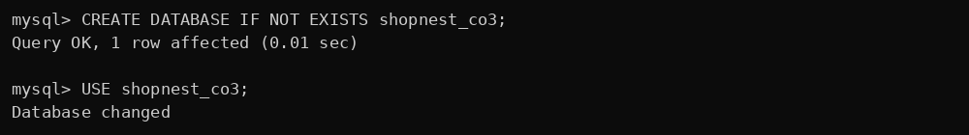
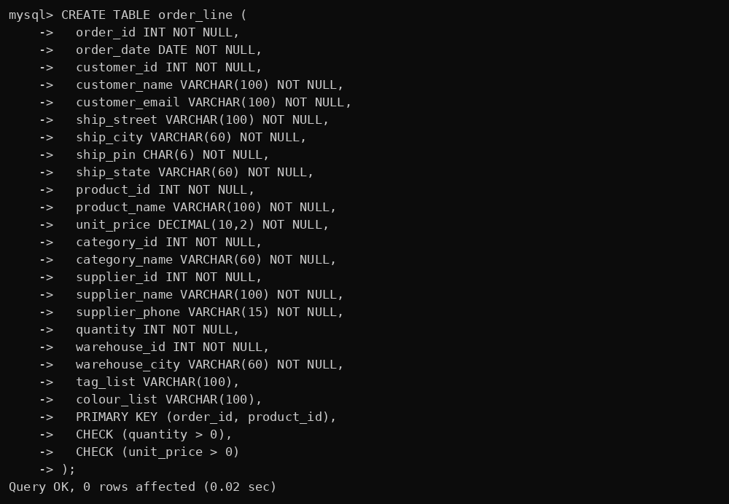
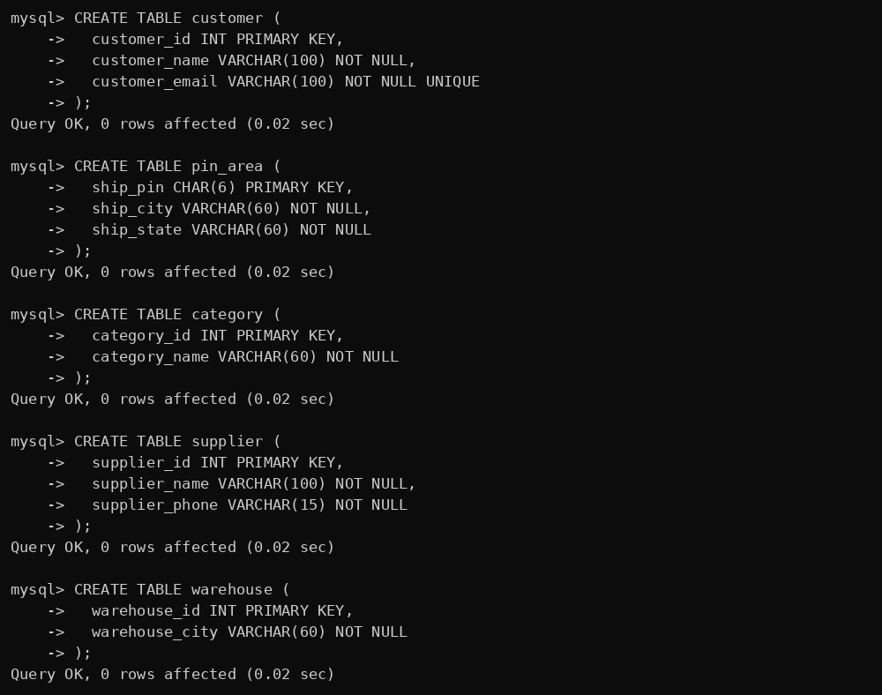
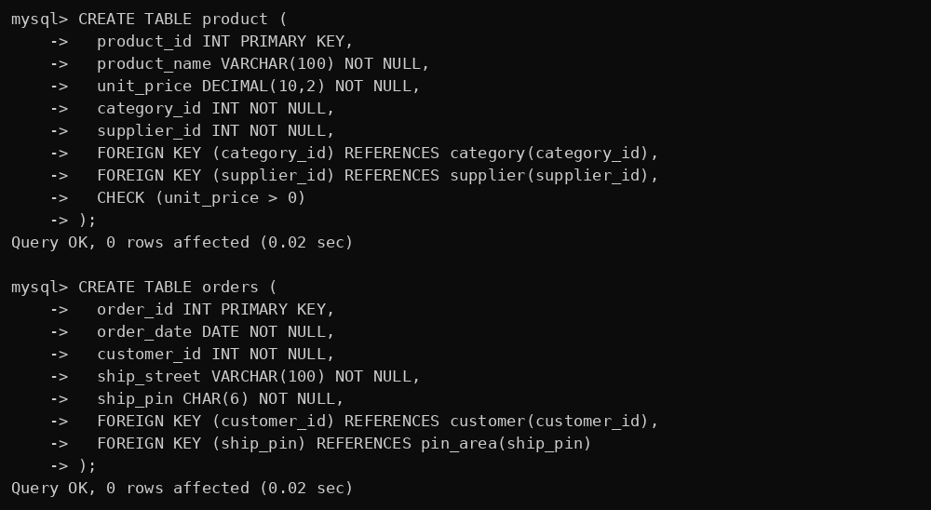
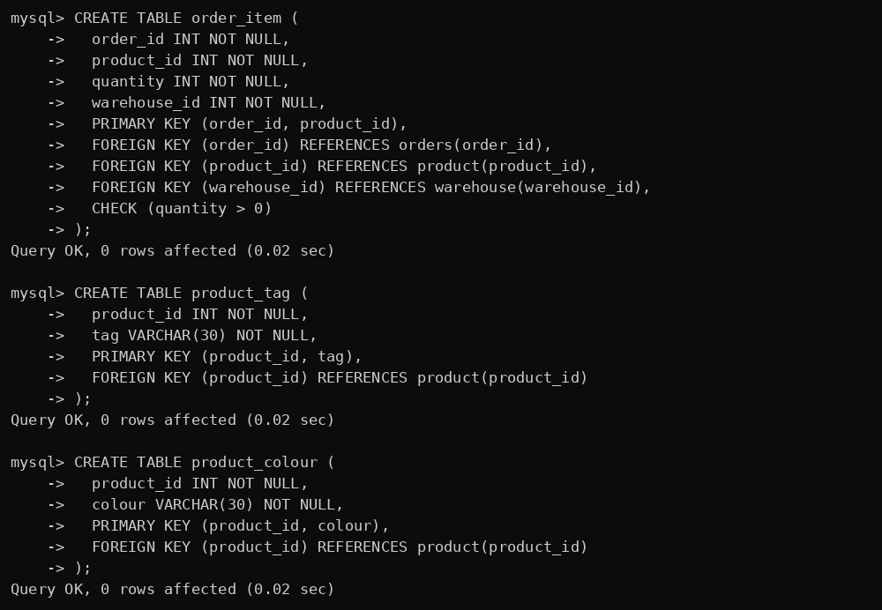
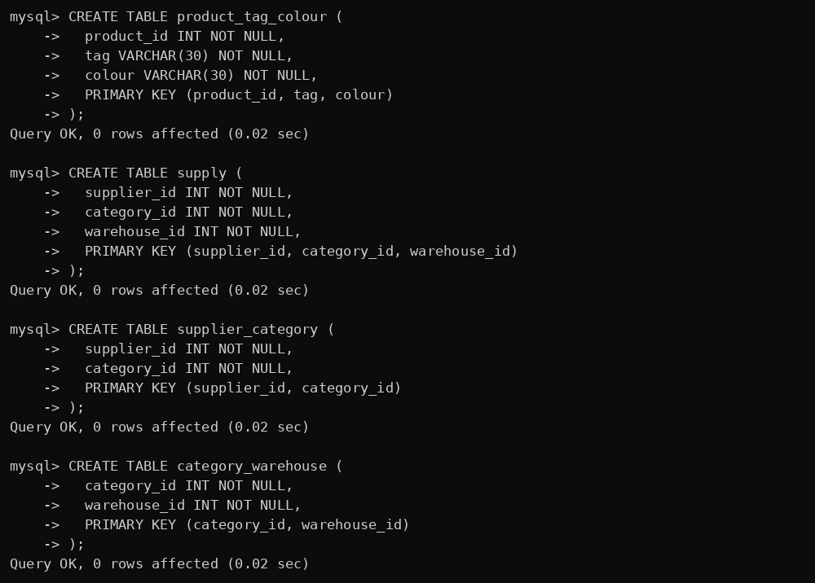
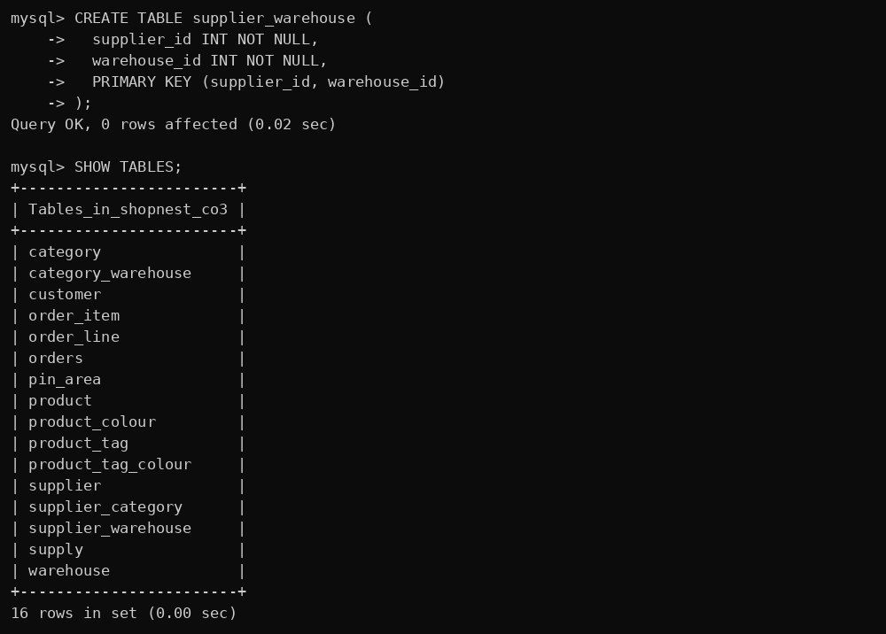

B. Insert sample data (12 order lines, unnormalised table)
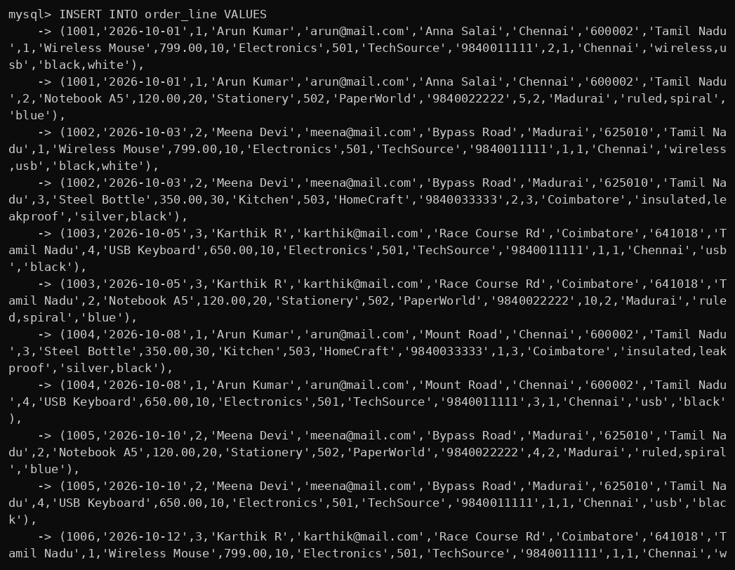
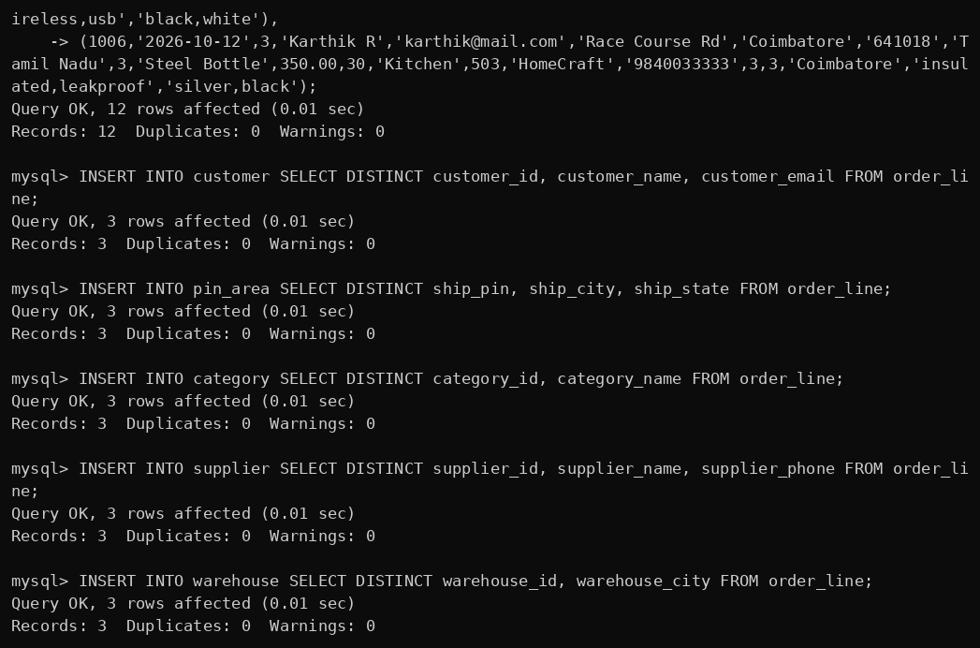
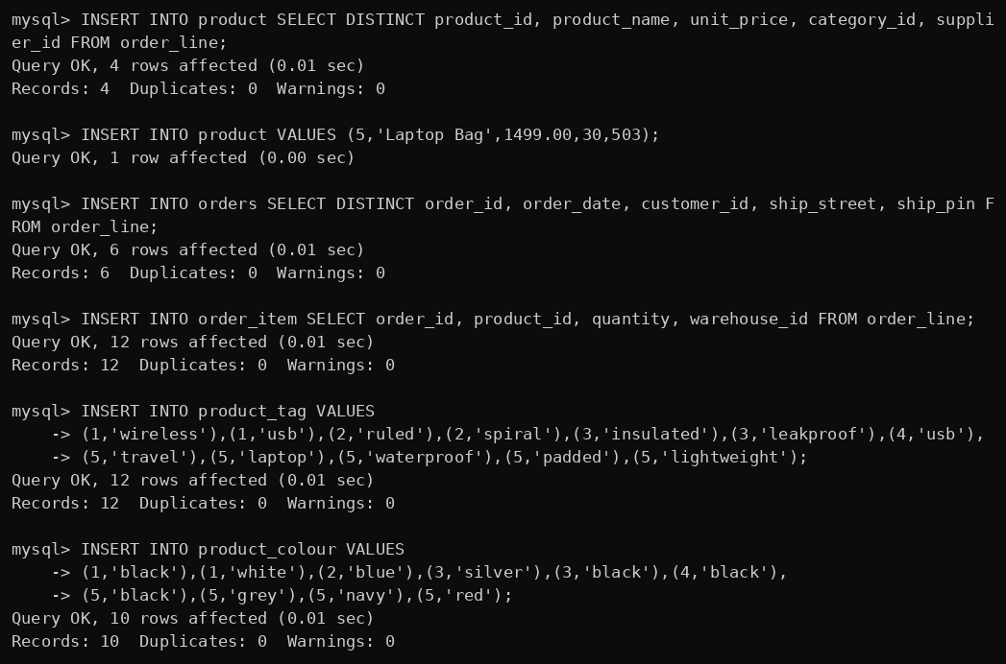
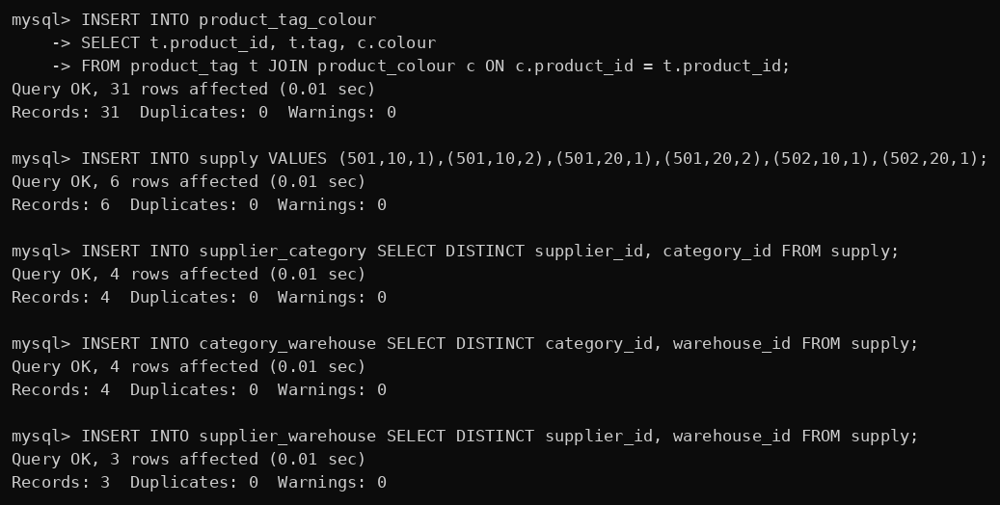

C. Row counts
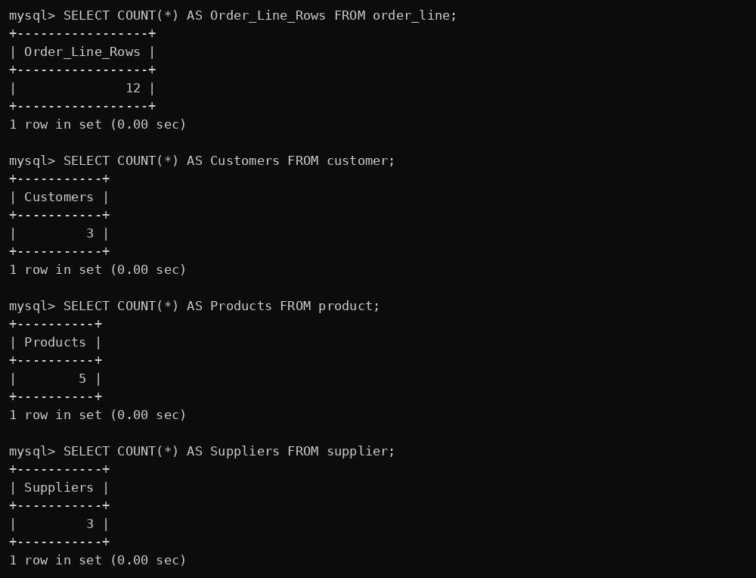
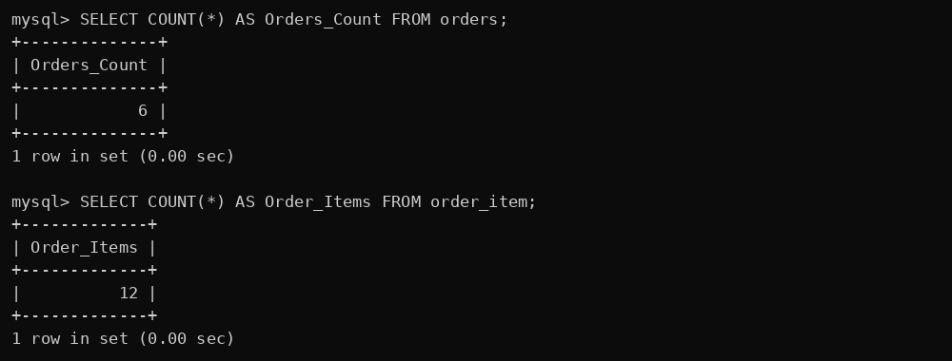

D. Task 1 and 3 – Functional dependency verification (0 rows = FD holds)
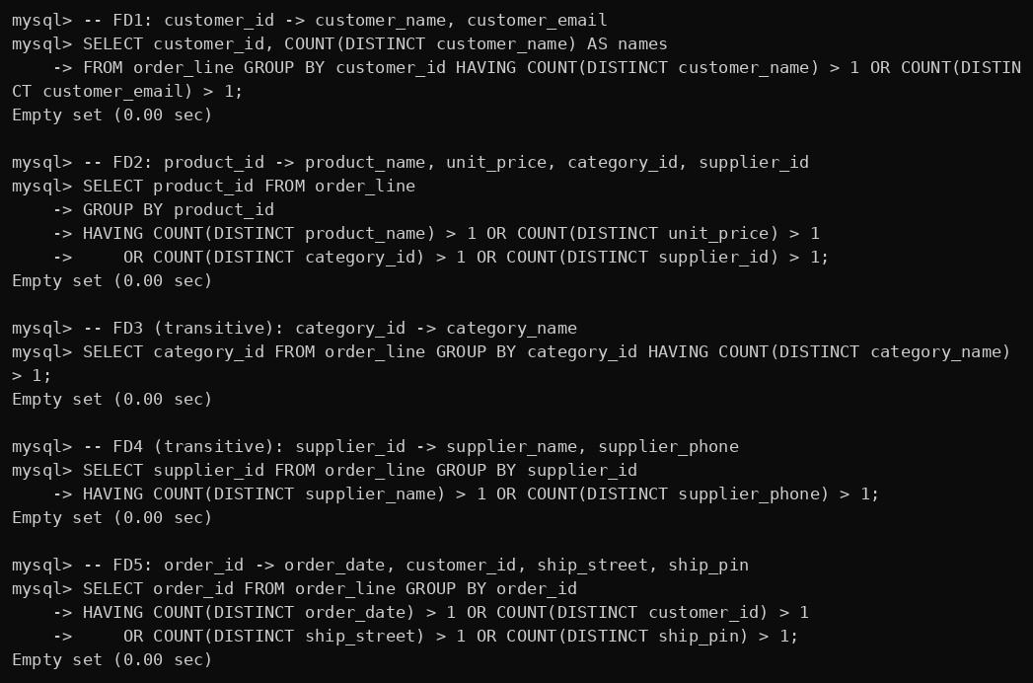
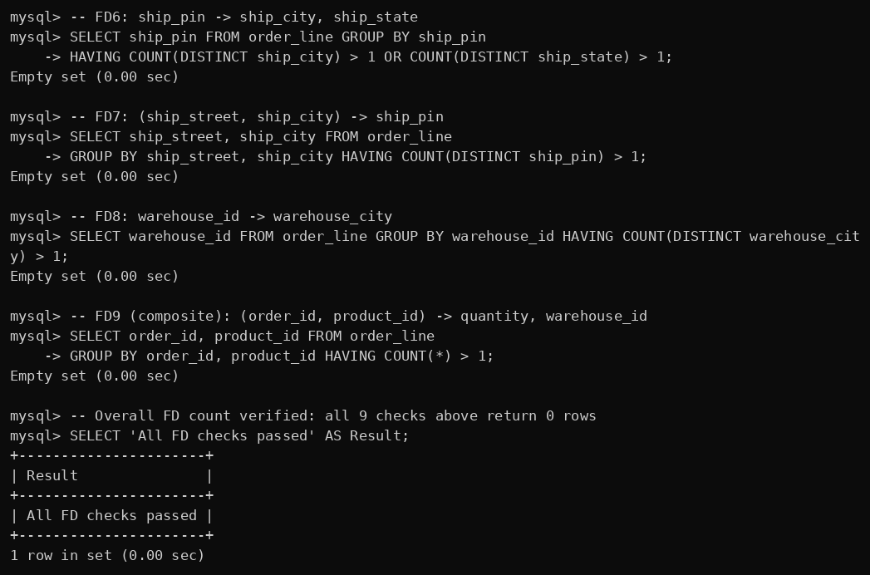

E. Task 2 – Redundancy: repeated copies of the same fact
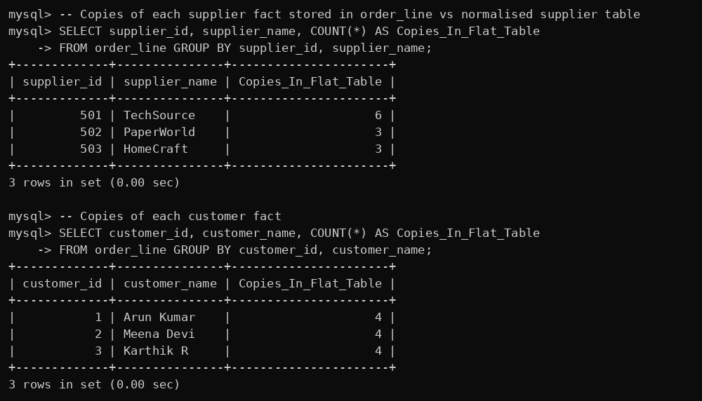
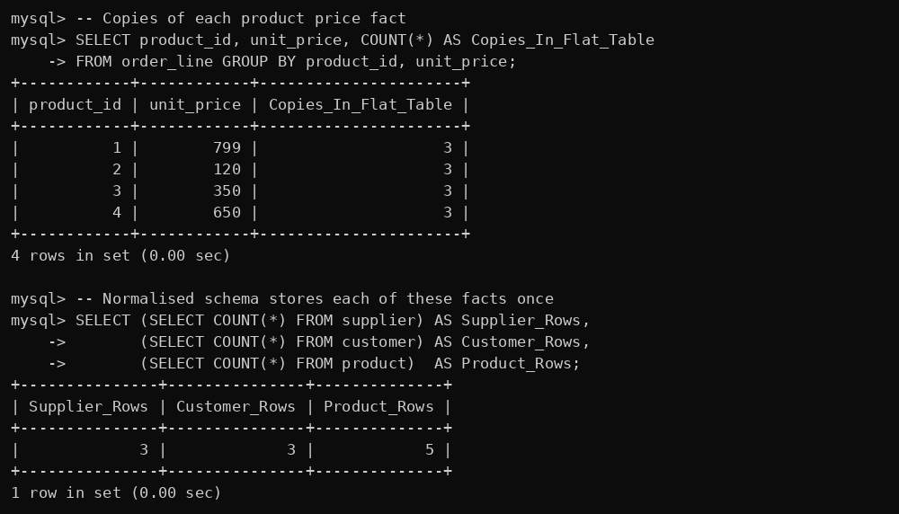

F. Task 5 – Lossless-join and dependency-preservation check (3NF/BCNF schema)
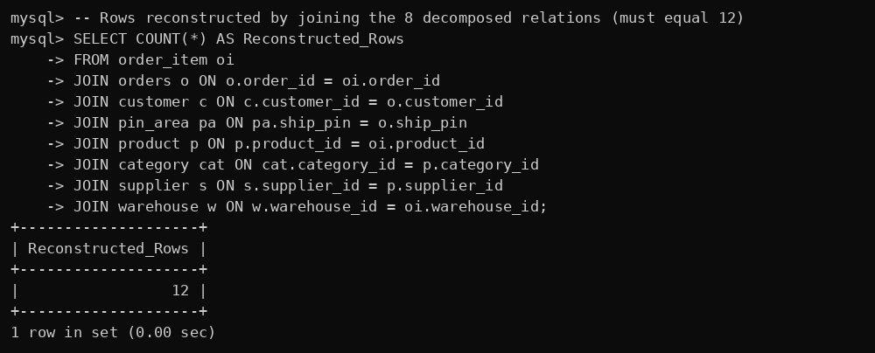
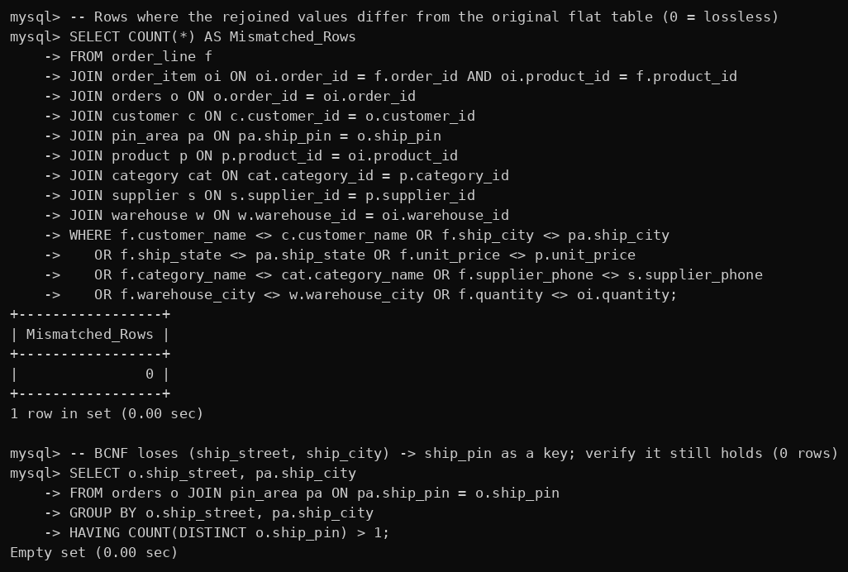

G. Task 2 and 8 – Anomalies reproduced on the unnormalised table
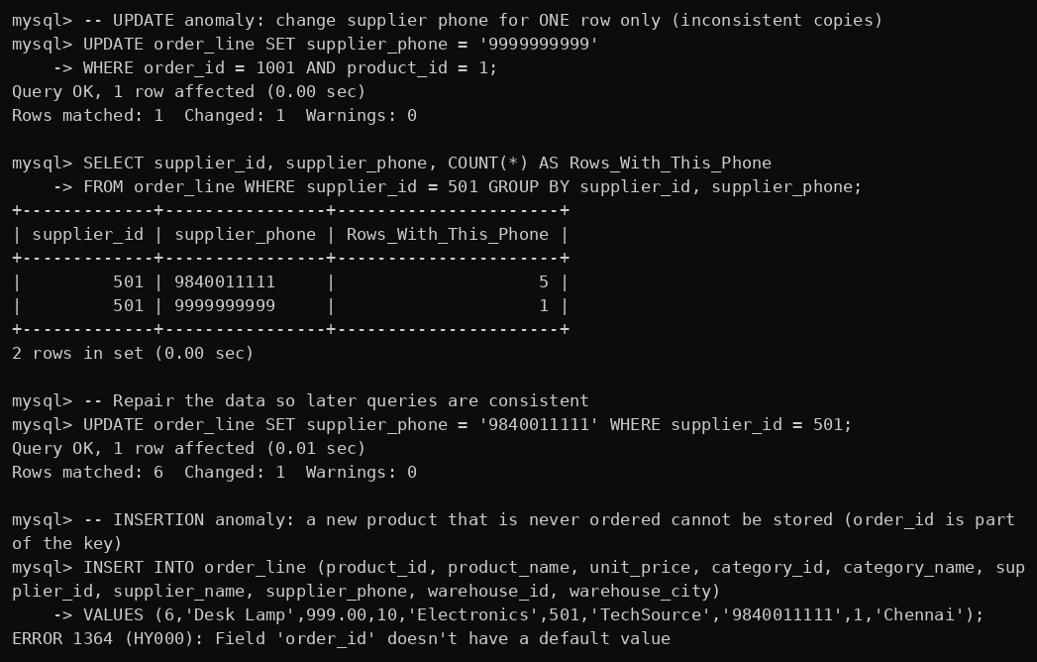
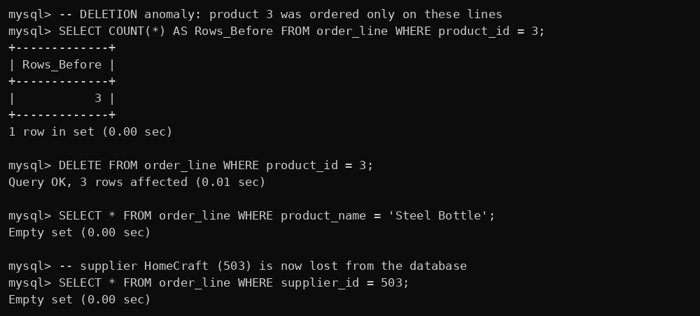

H. Task 8 – Same operations on the normalised schema (anomalies impossible) and boundary cases
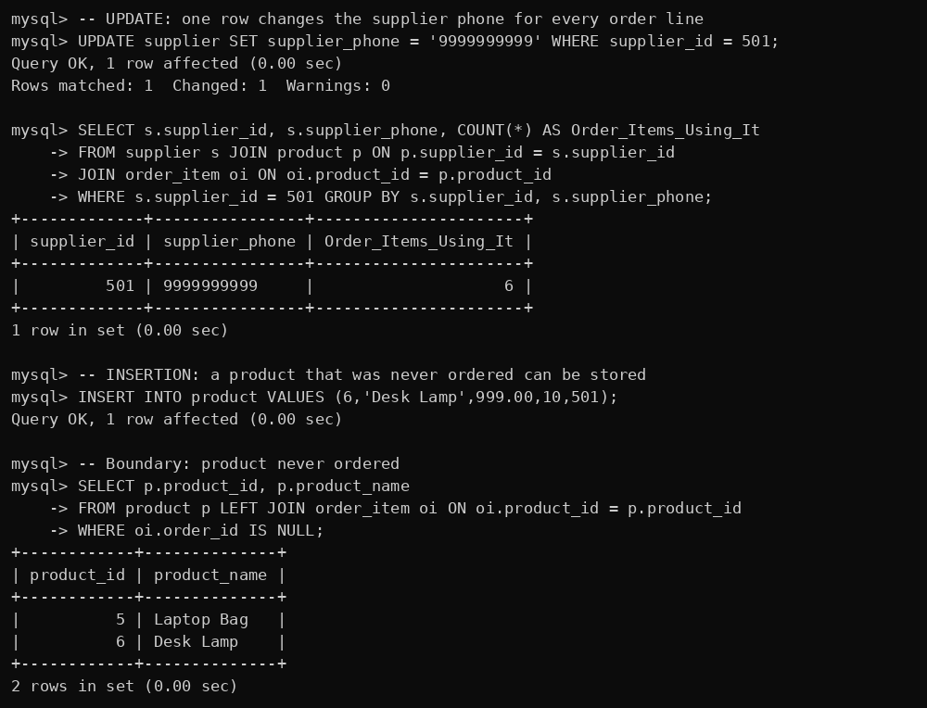
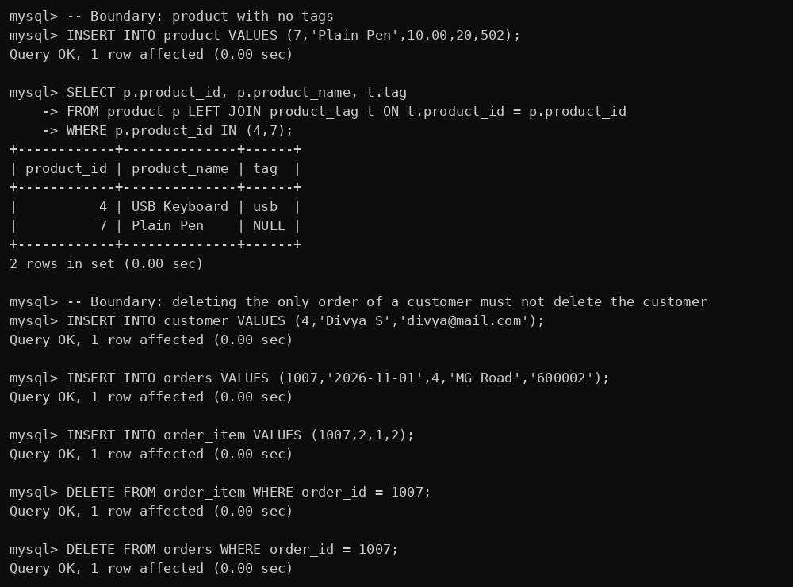
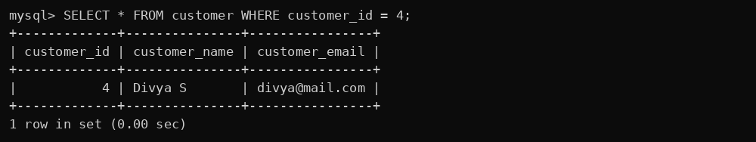

I. Task 6 – MVD and 4NF: row counts
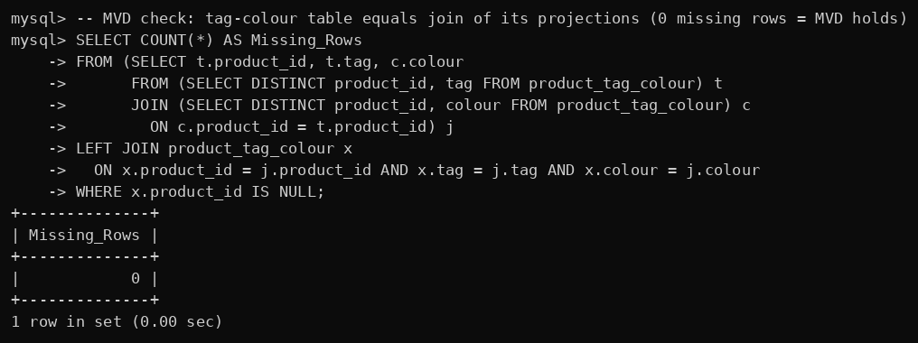
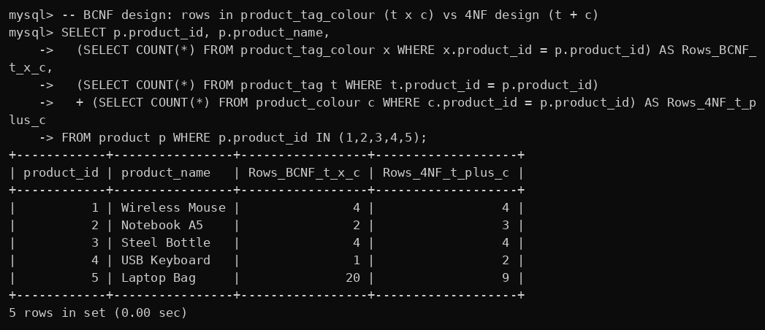

J. Task 7 – Join dependency and 5NF
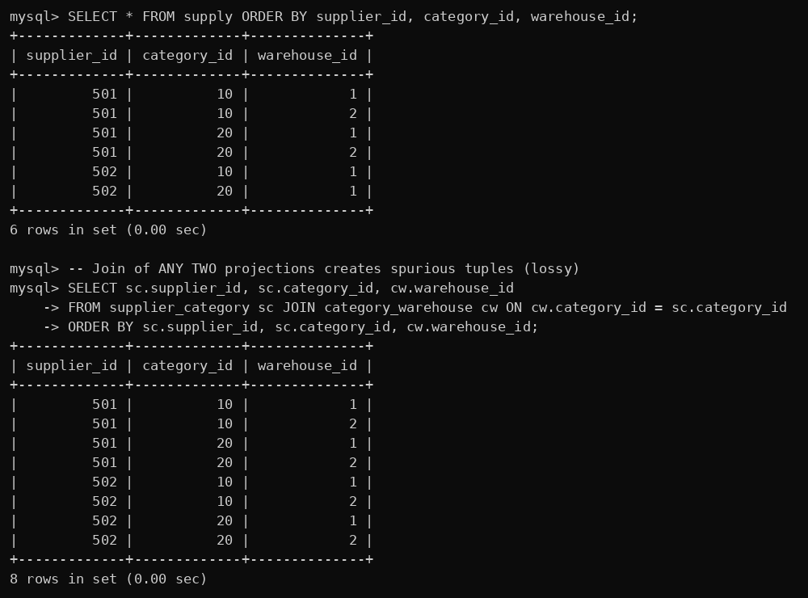
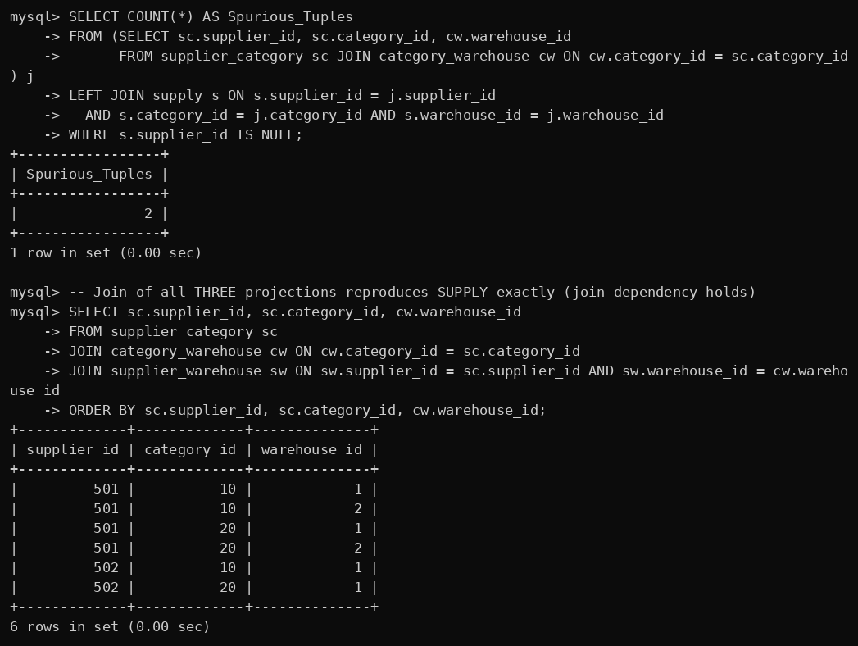
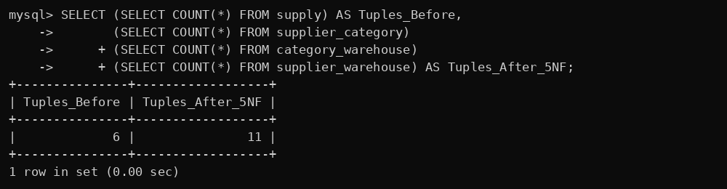

K. Invalid data tests (constraints)
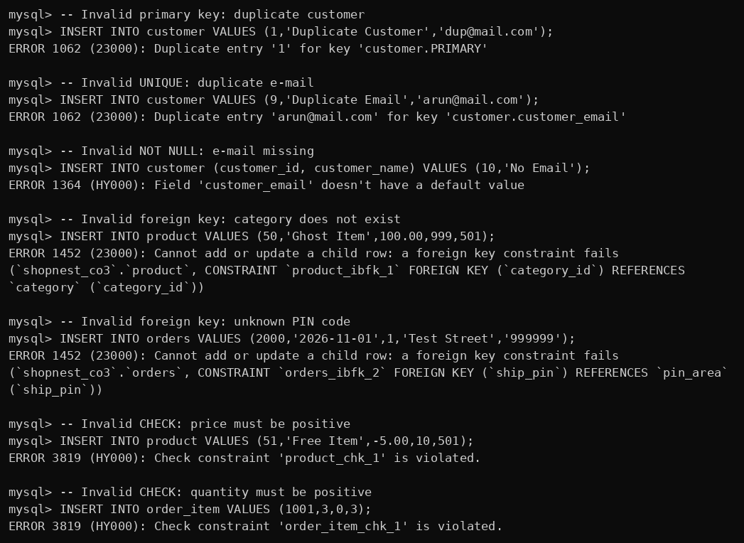

L. Task 12 – Changed requirement: price actually paid


